SQL Views

🌟 Definition
# Source: AI Source: Provided by: [Data Path: Persons Table -> ID Column: 1, Name_En Column: Motasem Essam] -> From: [ChatGPT] on [6/11/2026]
A SQL View is a virtual table created from the result of a SQL query.
A view does not usually store data itself. Instead, it displays data from one or more tables whenever it is queried.
Think of a view as a saved SQL query that can be treated like a table.

🎯 Purpose
# Source: AI Source: Provided by: [Data Path: Persons Table -> ID Column: 1, Name_En Column: Motasem Essam] -> From: [ChatGPT] on [6/11/2026]
SQL Views are used to:
- Simplify complex queries
- Hide sensitive data
- Improve readability
- Provide customized data views
- Reuse frequently used queries

🧠 Simple Example
# Source: AI Source: Provided by: [Data Path: Persons Table -> ID Column: 1, Name_En Column: Motasem Essam] -> From: [ChatGPT] on [6/11/2026]
Customers Table
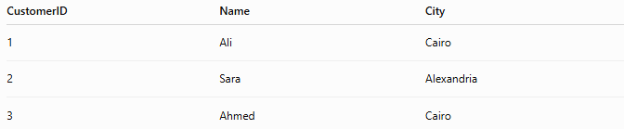
CustomerID | Name | City
1 | Ali | Cairo
2 | Sara | Alexandria
3 | Ahmed | Cairo

Create a View
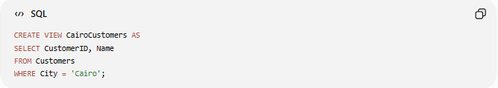
CREATE VIEW CairoCustomers AS
SELECT CustomerID, Name
FROM Customers
WHERE City = 'Cairo';

Query the View
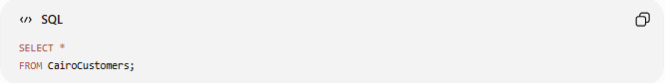
SELECT *
FROM CairoCustomers;

Result
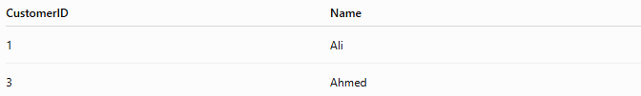
CustomerID | Name
1 | Ali
3 | Ahmed

🔍 How a View Works
# Source: AI Source: Provided by: [Data Path: Persons Table -> ID Column: 1, Name_En Column: Motasem Essam] -> From: [ChatGPT] on [6/11/2026]
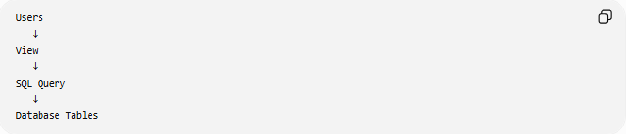
Users
↓
View
↓
SQL Query
↓
Database Tables
The view acts as a layer between users and the actual tables.

📝 Creating a View
# Source: AI Source: Provided by: [Data Path: Persons Table -> ID Column: 1, Name_En Column: Motasem Essam] -> From: [ChatGPT] on [6/11/2026]
Syntax
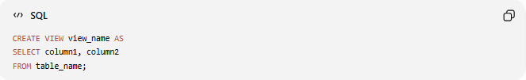
CREATE VIEW view_name AS
SELECT column1, column2
FROM table_name;

Example
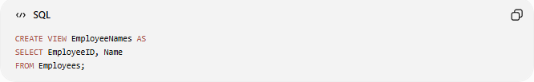
CREATE VIEW EmployeeNames AS
SELECT EmployeeID, Name
FROM Employees;

📖 Viewing Data from a View
# Source: AI Source: Provided by: [Data Path: Persons Table -> ID Column: 1, Name_En Column: Motasem Essam] -> From: [ChatGPT] on [6/11/2026]
A view is queried just like a table.
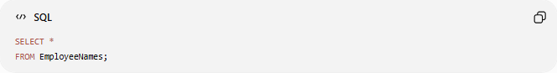
SELECT *
FROM EmployeeNames;

✏️ Updating a View
# Source: AI Source: Provided by: [Data Path: Persons Table -> ID Column: 1, Name_En Column: Motasem Essam] -> From: [ChatGPT] on [6/11/2026]
Some views can be updated.
Example:
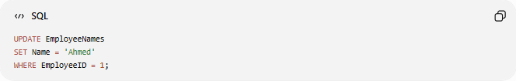
UPDATE EmployeeNames
SET Name = 'Ahmed'
WHERE EmployeeID = 1;
The underlying table is updated.

⚠️ Not all views are updatable.
Complex views involving joins, aggregates, or GROUP BY often cannot be updated directly.

🗑️ Deleting a View
# Source: AI Source: Provided by: [Data Path: Persons Table -> ID Column: 1, Name_En Column: Motasem Essam] -> From: [ChatGPT] on [6/11/2026]
Syntax
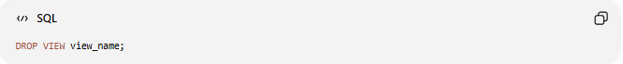
DROP VIEW view_name;

Example
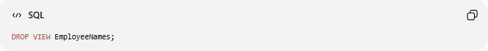
DROP VIEW EmployeeNames;

Result:
View removed
Table remains
Only the view is deleted.

📚 Real-World Example
# Source: AI Source: Provided by: [Data Path: Persons Table -> ID Column: 1, Name_En Column: Motasem Essam] -> From: [ChatGPT] on [6/11/2026]
Employees Table
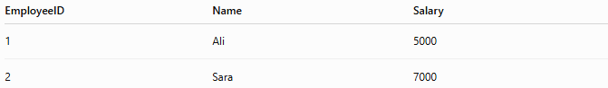
EmployeeID | Name | Salary
1 | Ali | 5000
2 | Sara | 7000

Suppose employees should not see salary information.
Create a view:
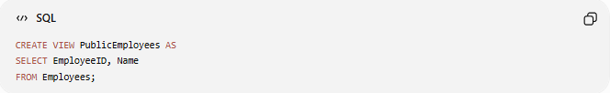
CREATE VIEW PublicEmployees AS
SELECT EmployeeID, Name
FROM Employees;

Users query:
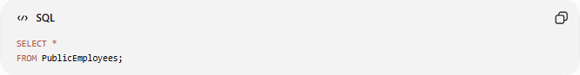
SELECT *
FROM PublicEmployees;

Result:
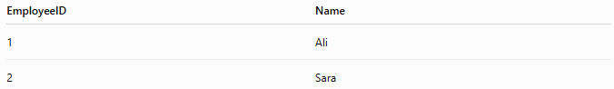
EmployeeID | Name
1 | Ali
2 | Sara
Salary remains hidden.

🔒 Views for Security
# Source: AI Source: Provided by: [Data Path: Persons Table -> ID Column: 1, Name_En Column: Motasem Essam] -> From: [ChatGPT] on [6/11/2026]
Views can restrict access.
Instead of giving access to:
Employees Table
give access to:
PublicEmployees View
Only selected columns become visible.

🔗 Views Using Multiple Tables
# Source: AI Source: Provided by: [Data Path: Persons Table -> ID Column: 1, Name_En Column: Motasem Essam] -> From: [ChatGPT] on [6/11/2026]
Customers
CustomerID | Name
1 | Ali

Orders
OrderID | CustomerID
1001 | 1

View
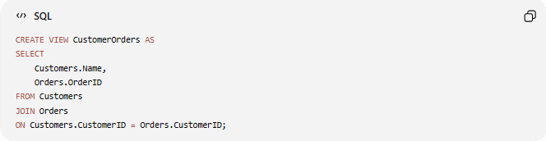
CREATE VIEW CustomerOrders AS
SELECT
Customers.Name,
Orders.OrderID
FROM Customers
JOIN Orders
ON Customers.CustomerID = Orders.CustomerID;

Result
Name | OrderID
Ali | 1001

📊 Side-by-Side Comparison
# Source: AI Source: Provided by: [Data Path: Persons Table -> ID Column: 1, Name_En Column: Motasem Essam] -> From: [ChatGPT] on [6/11/2026]
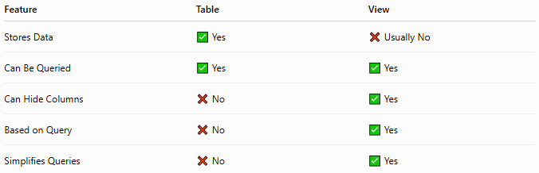
Feature | Table | View
Stores Data | ✅ Yes | ❌ Usually No
Can Be Queried | ✅ Yes | ✅ Yes
Can Hide Columns | ❌ No | ✅ Yes
Based on Query | ❌ No | ✅ Yes
Simplifies Queries | ❌ No | ✅ Yes

🛠️ Common View Operations
# Source: AI Source: Provided by: [Data Path: Persons Table -> ID Column: 1, Name_En Column: Motasem Essam] -> From: [ChatGPT] on [6/11/2026]
Create View
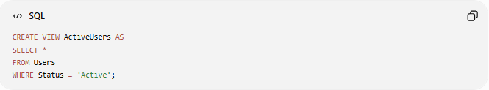
CREATE VIEW ActiveUsers AS
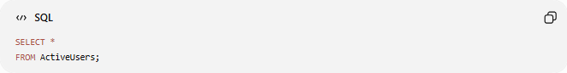
SELECT *
FROM Users
WHERE Status = 'Active';

Query View

SELECT *
FROM ActiveUsers;

Delete View
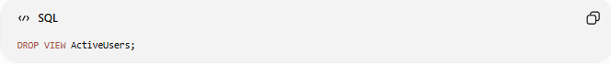
DROP VIEW ActiveUsers;

🌍 Example: Online Store
Products Table
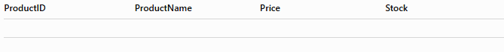
ProductID | ProductName | Price | Stock

Create a customer-friendly view:
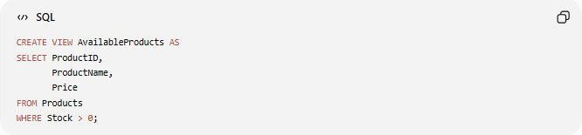
CREATE VIEW AvailableProducts AS
SELECT ProductID,
ProductName,
Price
FROM Products
WHERE Stock > 0;

Customers see only products currently available.

⚠️ Advantages and Disadvantages

✅ Advantages
# Source: AI Source: Provided by: [Data Path: Persons Table -> ID Column: 1, Name_En Column: Motasem Essam] -> From: [ChatGPT] on [6/11/2026]
- Simplifies complex queries
- Improves security
- Provides reusable query logic
- Hides unnecessary columns
- Presents customized data

❌ Disadvantages
# Source: AI Source: Provided by: [Data Path: Persons Table -> ID Column: 1, Name_En Column: Motasem Essam] -> From: [ChatGPT] on [6/11/2026]
- Complex views may be slower
- Some views cannot be updated
- Too many views can make maintenance harder

🧪 Example

Full Example
# Source: AI Source: Provided by: [Data Path: Persons Table -> ID Column: 1, Name_En Column: Motasem Essam] -> From: [ChatGPT] on [6/11/2026]
Complete SQL View Example (Create, Query, Update, Replace, Drop)
You can run these queries step-by-step to learn and test SQL Views.

prepared commands

1️⃣ Create a Table
# Source: AI Source: Provided by: [Data Path: Persons Table -> ID Column: 1, Name_En Column: Motasem Essam] -> From: [ChatGPT] on [6/11/2026]
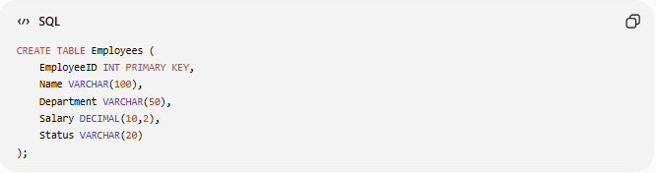
CREATE TABLE Employees (
EmployeeID INT PRIMARY KEY,
Name VARCHAR(100),
Department VARCHAR(50),
Salary DECIMAL(10,2),
Status VARCHAR(20)
);

2️⃣ Insert Sample Data
# Source: AI Source: Provided by: [Data Path: Persons Table -> ID Column: 1, Name_En Column: Motasem Essam] -> From: [ChatGPT] on [6/11/2026]
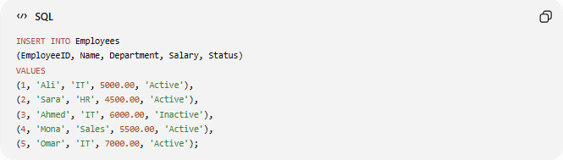
INSERT INTO Employees
(EmployeeID, Name, Department, Salary, Status)
VALUES
(1, 'Ali', 'IT', 5000.00, 'Active'),
(2, 'Sara', 'HR', 4500.00, 'Active'),
(3, 'Ahmed', 'IT', 6000.00, 'Inactive'),
(4, 'Mona', 'Sales', 5500.00, 'Active'),
(5, 'Omar', 'IT', 7000.00, 'Active');

basic command

3️⃣ Create a View
# Source: AI Source: Provided by: [Data Path: Persons Table -> ID Column: 1, Name_En Column: Motasem Essam] -> From: [ChatGPT] on [6/11/2026]
Show only active employees.
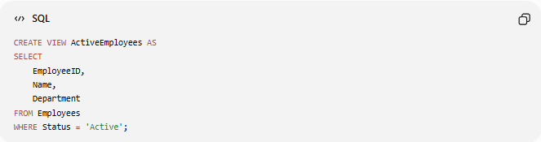
CREATE VIEW ActiveEmployees AS
SELECT
EmployeeID,
Name,
Department
FROM Employees
WHERE Status = 'Active';

4️⃣ Query the View
# Source: AI Source: Provided by: [Data Path: Persons Table -> ID Column: 1, Name_En Column: Motasem Essam] -> From: [ChatGPT] on [6/11/2026]
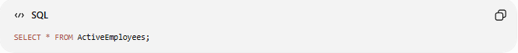
SELECT * FROM ActiveEmployees;
Expected Result:
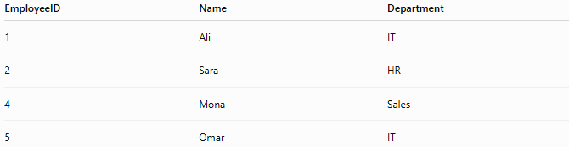
EmployeeID | Name | Department
1 | Ali | IT
2 | Sara | HR
4 | Mona | Sales
5 | Omar | IT

6️⃣ Create Another View
# Source: AI Source: Provided by: [Data Path: Persons Table -> ID Column: 1, Name_En Column: Motasem Essam] -> From: [ChatGPT] on [6/11/2026]
Hide salary information from users.
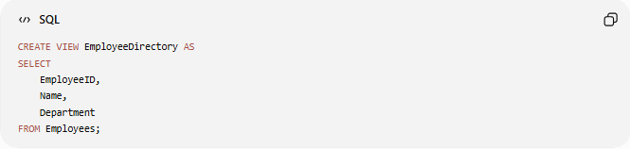
CREATE VIEW EmployeeDirectory AS
SELECT
EmployeeID,
Name,
Department
FROM Employees;

8️⃣ Query the Second View
# Source: AI Source: Provided by: [Data Path: Persons Table -> ID Column: 1, Name_En Column: Motasem Essam] -> From: [ChatGPT] on [6/11/2026]
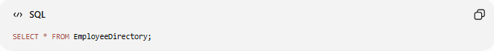
SELECT * FROM EmployeeDirectory;

5️⃣ Create a View with Calculated Data
# Source: AI Source: Provided by: [Data Path: Persons Table -> ID Column: 1, Name_En Column: Motasem Essam] -> From: [ChatGPT] on [6/11/2026]
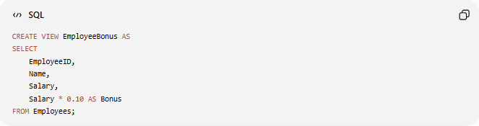
CREATE VIEW EmployeeBonus AS
SELECT
EmployeeID,
Name,
Salary,
Salary * 0.10 AS Bonus
FROM Employees;

6️⃣ Update Data in the Base Table
# Source: AI Source: Provided by: [Data Path: Persons Table -> ID Column: 1, Name_En Column: Motasem Essam] -> From: [ChatGPT] on [6/11/2026]
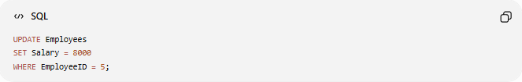
UPDATE Employees
SET Salary = 8000
WHERE EmployeeID = 5;

7️⃣ Query the View Again
# Source: AI Source: Provided by: [Data Path: Persons Table -> ID Column: 1, Name_En Column: Motasem Essam] -> From: [ChatGPT] on [6/11/2026]
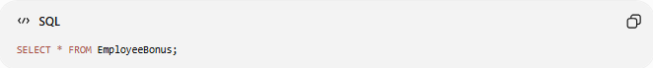
SELECT * FROM EmployeeBonus;
Notice that Omar's bonus updates automatically.
EmployeeID | Name | Salary | Bonus
5 | Omar | 8000 | 800

8️⃣ Create a View Using ORDER BY
# Source: AI Source: Provided by: [Data Path: Persons Table -> ID Column: 1, Name_En Column: Motasem Essam] -> From: [ChatGPT] on [6/11/2026]
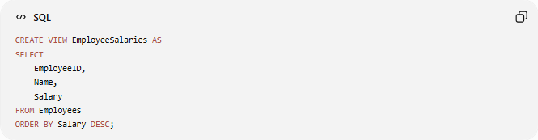
CREATE VIEW EmployeeSalaries AS
SELECT
EmployeeID,
Name,
Salary
FROM Employees
ORDER BY Salary DESC;

9️⃣ Replace a View (MySQL)
# Source: AI Source: Provided by: [Data Path: Persons Table -> ID Column: 1, Name_En Column: Motasem Essam] -> From: [ChatGPT] on [6/11/2026]
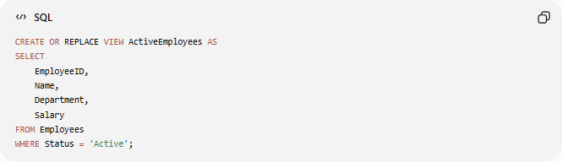
CREATE OR REPLACE VIEW ActiveEmployees AS
SELECT
EmployeeID,
Name,
Department,
Salary
FROM Employees
WHERE Status = 'Active';

🔟 Show View Definition
# Source: AI Source: Provided by: [Data Path: Persons Table -> ID Column: 1, Name_En Column: Motasem Essam] -> From: [ChatGPT] on [6/11/2026]
(MySQL)
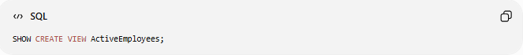
SHOW CREATE VIEW ActiveEmployees;

1️⃣1️⃣ List All Views
# Source: AI Source: Provided by: [Data Path: Persons Table -> ID Column: 1, Name_En Column: Motasem Essam] -> From: [ChatGPT] on [6/11/2026]
(MySQL)
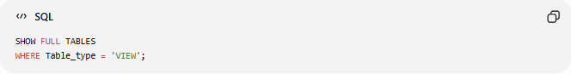
SHOW FULL TABLES
WHERE Table_type = 'VIEW';

1️⃣2️⃣ Delete a View
# Source: AI Source: Provided by: [Data Path: Persons Table -> ID Column: 1, Name_En Column: Motasem Essam] -> From: [ChatGPT] on [6/11/2026]
Delete Single View
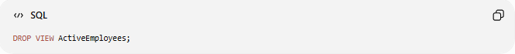
DROP VIEW ActiveEmployees;

Delete Multiple Views
# Source: AI Source: Provided by: [Data Path: Persons Table -> ID Column: 1, Name_En Column: Motasem Essam] -> From: [ChatGPT] on [6/11/2026]
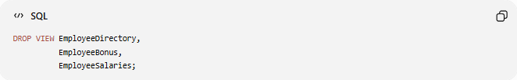
DROP VIEW EmployeeDirectory,
EmployeeBonus,
EmployeeSalaries;

1️⃣3️⃣ Verify Views Were Removed
# Source: AI Source: Provided by: [Data Path: Persons Table -> ID Column: 1, Name_En Column: Motasem Essam] -> From: [ChatGPT] on [6/11/2026]
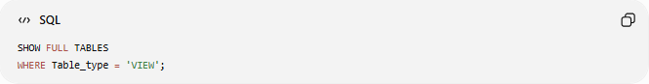
SHOW FULL TABLES
WHERE Table_type = 'VIEW';
Expected Result:
Empty set

📋 SQL View Commands Summary
# Source: AI Source: Provided by: [Data Path: Persons Table -> ID Column: 1, Name_En Column: Motasem Essam] -> From: [ChatGPT] on [6/11/2026]
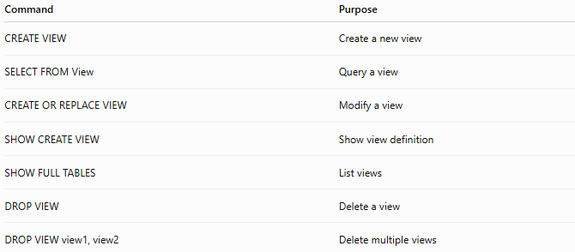
Command | Purpose
CREATE VIEW | Create a new view
SELECT FROM View | Query a view
CREATE OR REPLACE VIEW | Modify a view
SHOW CREATE VIEW | Show view definition
SHOW FULL TABLES | List views
DROP VIEW | Delete a view
DROP VIEW view1, view2 | Delete multiple views

🚀 Complete Testing Flow
# Source: AI Source: Provided by: [Data Path: Persons Table -> ID Column: 1, Name_En Column: Motasem Essam] -> From: [ChatGPT] on [6/11/2026]
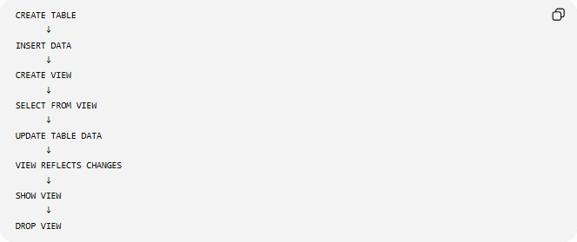
CREATE TABLE
↓
INSERT DATA
↓
CREATE VIEW
↓
SELECT FROM VIEW
↓
UPDATE TABLE DATA
↓
VIEW REFLECTS CHANGES
↓
SHOW VIEW
↓
DROP VIEW

Real Example

prepared commands

1️⃣ Create a Table
# Source: ScreenShot Source: Provided by: [Persons Table -> ID Column: 1, Name_En Column: Motasem Essam] -> Tool: [Automation Table -> ID Column: 16, Name_En Column: Screen Capture] -> From [Operating System: Wampserver64 -> phpmyadmin] on [6/11/2026]
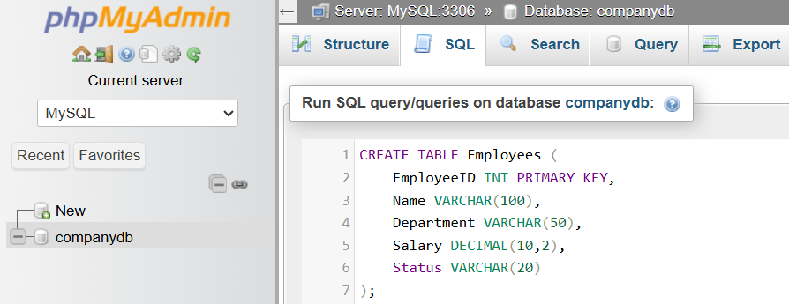
CREATE TABLE Employees (
EmployeeID INT PRIMARY KEY,
Name VARCHAR(100),
Department VARCHAR(50),
Salary DECIMAL(10,2),
Status VARCHAR(20)
);
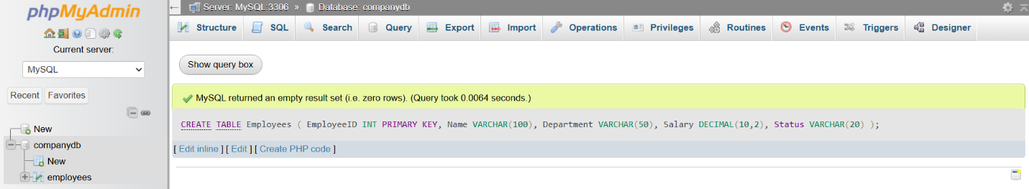

2️⃣ Insert Sample Data
# Source: ScreenShot Source: Provided by: [Persons Table -> ID Column: 1, Name_En Column: Motasem Essam] -> Tool: [Automation Table -> ID Column: 16, Name_En Column: Screen Capture] -> From [Operating System: Wampserver64 -> phpmyadmin] on [6/11/2026]
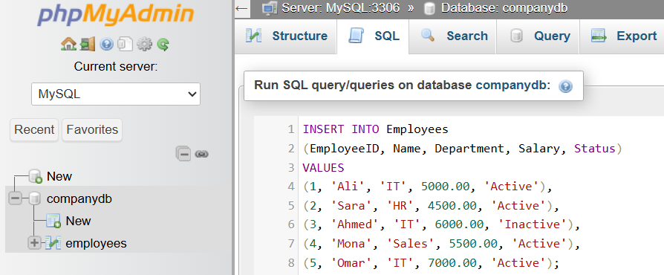
INSERT INTO Employees
(EmployeeID, Name, Department, Salary, Status)
VALUES
(1, 'Ali', 'IT', 5000.00, 'Active'),
(2, 'Sara', 'HR', 4500.00, 'Active'),
(3, 'Ahmed', 'IT', 6000.00, 'Inactive'),
(4, 'Mona', 'Sales', 5500.00, 'Active'),
(5, 'Omar', 'IT', 7000.00, 'Active');
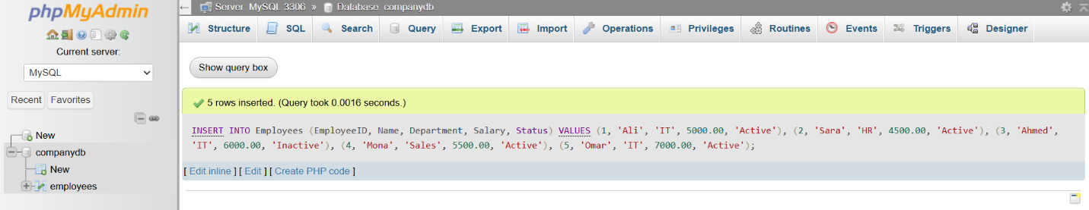
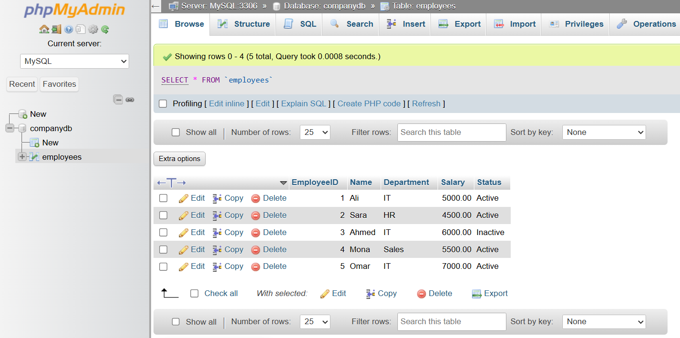

3️⃣ Create a View
# Source: ScreenShot Source: Provided by: [Persons Table -> ID Column: 1, Name_En Column: Motasem Essam] -> Tool: [Automation Table -> ID Column: 16, Name_En Column: Screen Capture] -> From [Operating System: Wampserver64 -> phpmyadmin] on [6/11/2026]
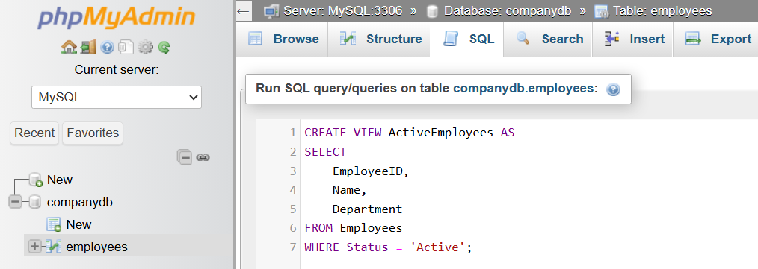
CREATE VIEW ActiveEmployees AS
SELECT
EmployeeID,
Name,
Department
FROM Employees
WHERE Status = 'Active';
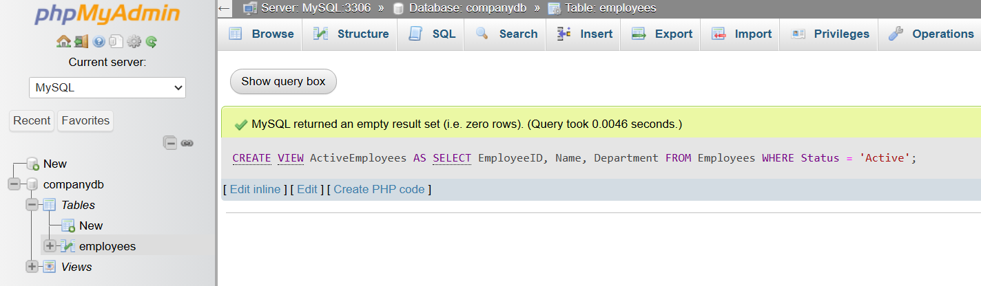
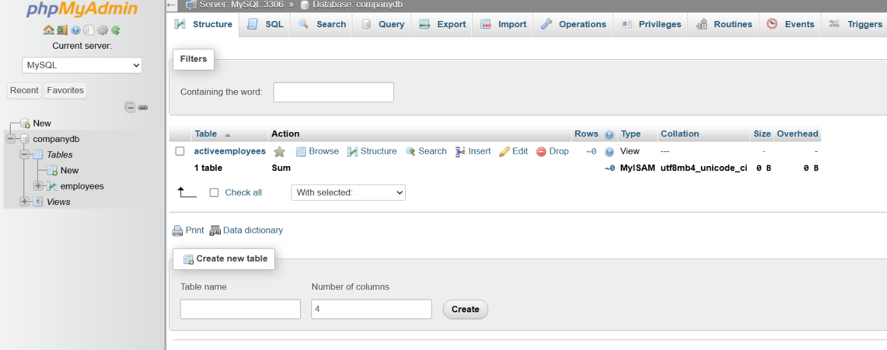
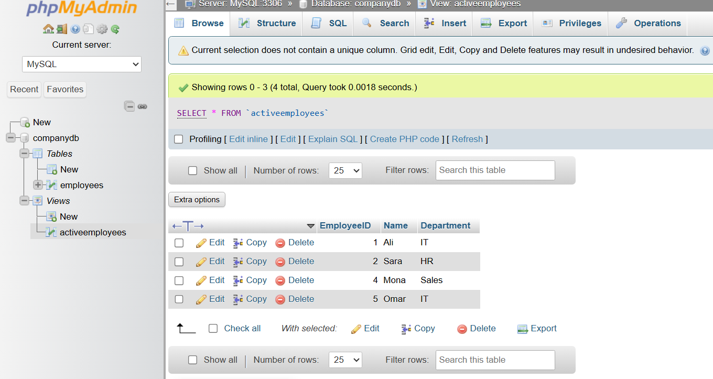

4️⃣ Query the View
# Source: ScreenShot Source: Provided by: [Persons Table -> ID Column: 1, Name_En Column: Motasem Essam] -> Tool: [Automation Table -> ID Column: 16, Name_En Column: Screen Capture] -> From [Operating System: Wampserver64 -> phpmyadmin] on [6/11/2026]
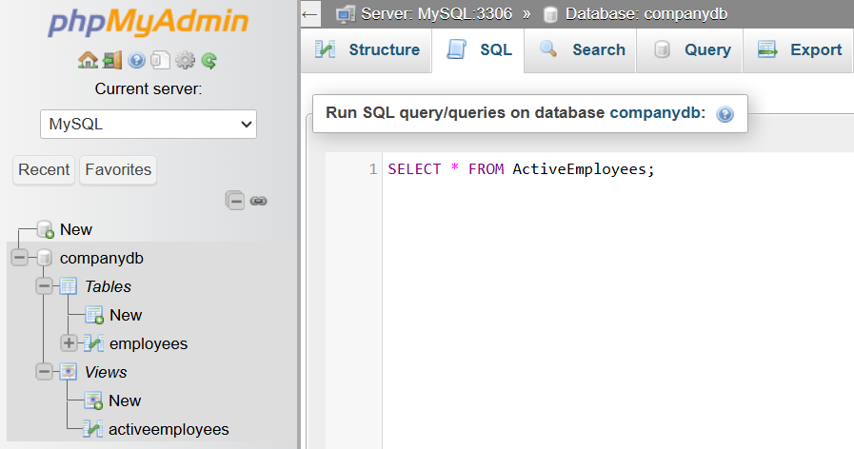
SELECT * FROM ActiveEmployees;
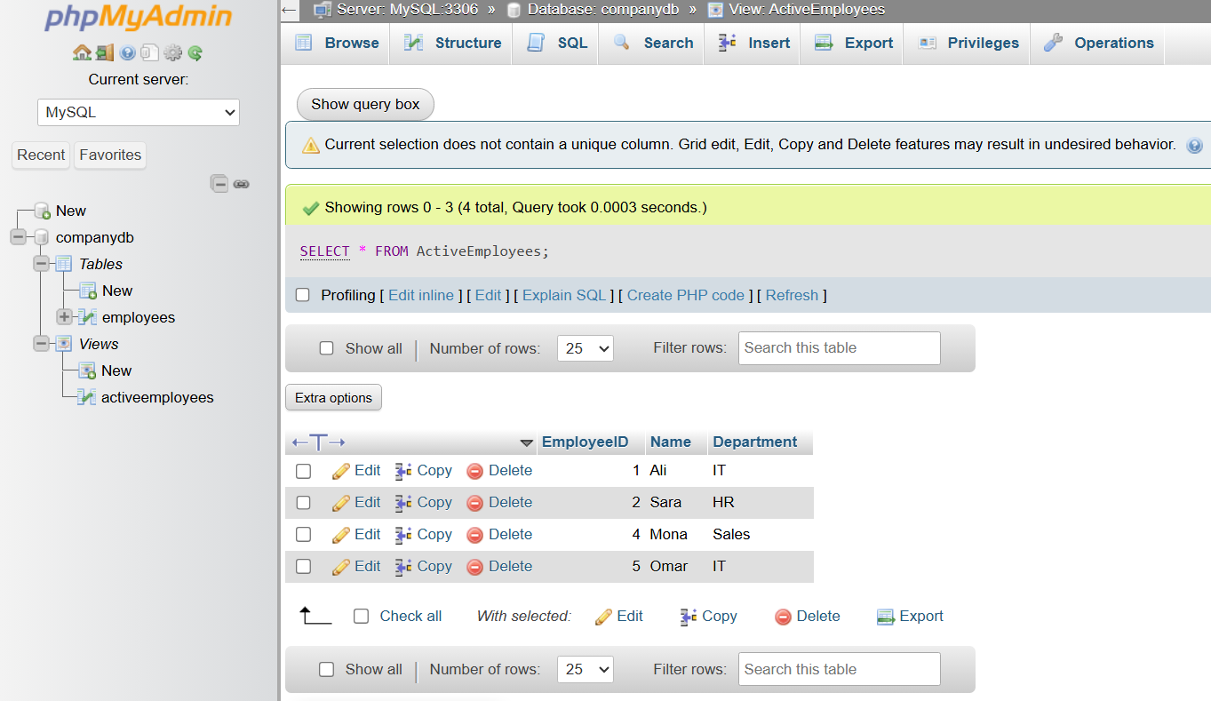

5️⃣ Create a View with Calculated Data
# Source: ScreenShot Source: Provided by: [Persons Table -> ID Column: 1, Name_En Column: Motasem Essam] -> Tool: [Automation Table -> ID Column: 16, Name_En Column: Screen Capture] -> From [Operating System: Wampserver64 -> phpmyadmin] on [6/11/2026]
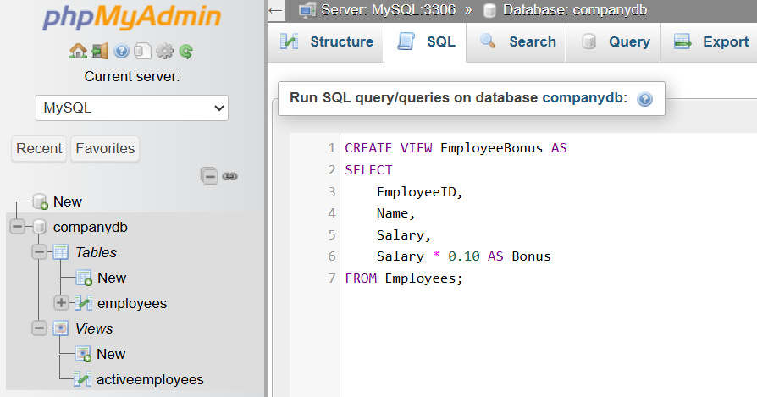
CREATE VIEW EmployeeBonus AS
SELECT
EmployeeID,
Name,
Salary,
Salary * 0.10 AS Bonus
FROM Employees;
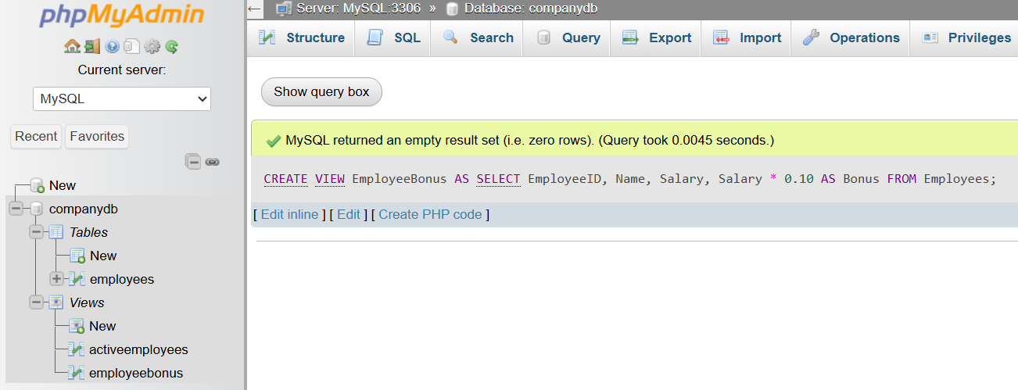
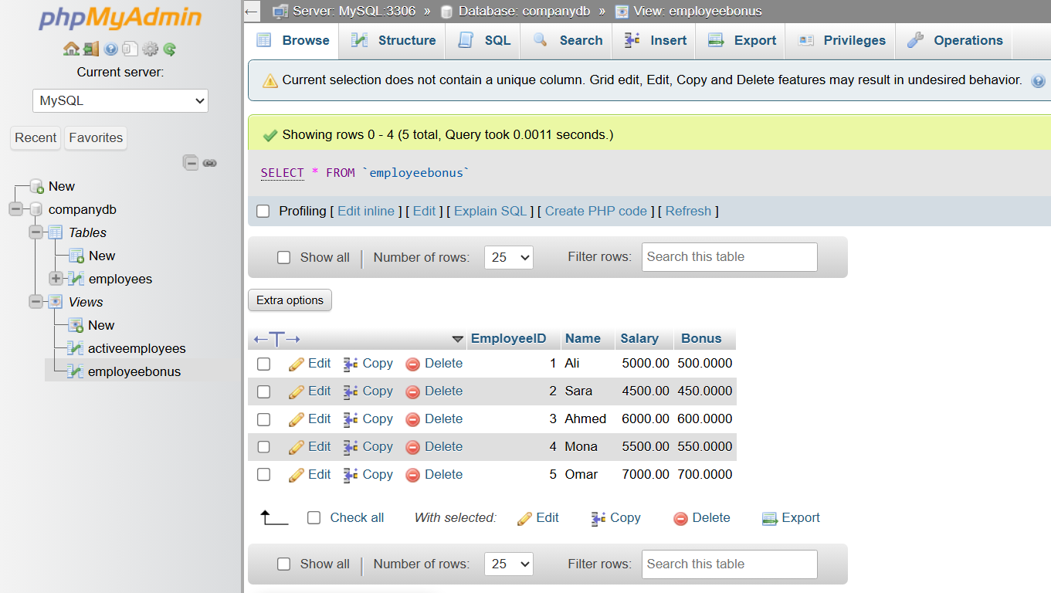

6️⃣ Update Data in the Base Table
# Source: ScreenShot Source: Provided by: [Persons Table -> ID Column: 1, Name_En Column: Motasem Essam] -> Tool: [Automation Table -> ID Column: 16, Name_En Column: Screen Capture] -> From [Operating System: Wampserver64 -> phpmyadmin] on [6/11/2026]
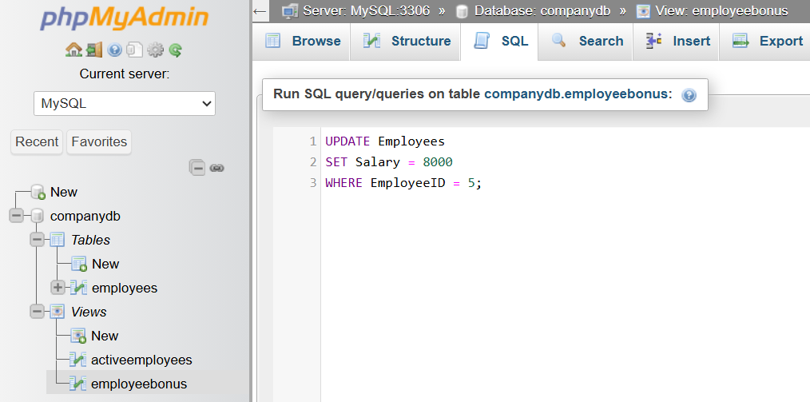
UPDATE Employees
SET Salary = 8000
WHERE EmployeeID = 5;
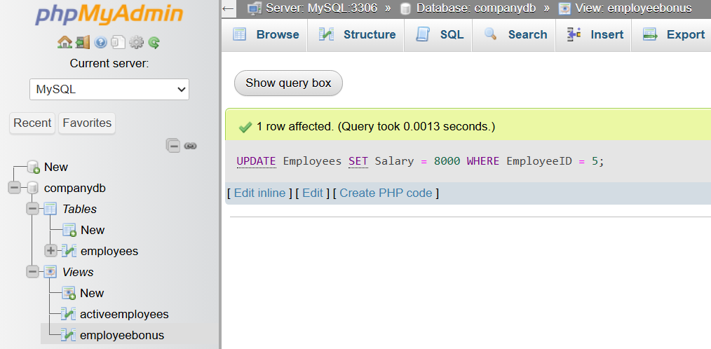

7️⃣ Query the View Again
# Source: ScreenShot Source: Provided by: [Persons Table -> ID Column: 1, Name_En Column: Motasem Essam] -> Tool: [Automation Table -> ID Column: 16, Name_En Column: Screen Capture] -> From [Operating System: Wampserver64 -> phpmyadmin] on [6/11/2026]
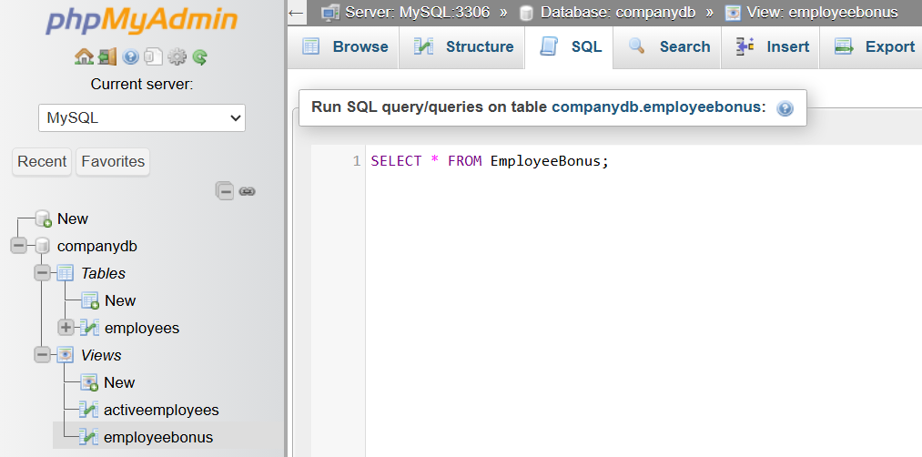
SELECT * FROM EmployeeBonus;
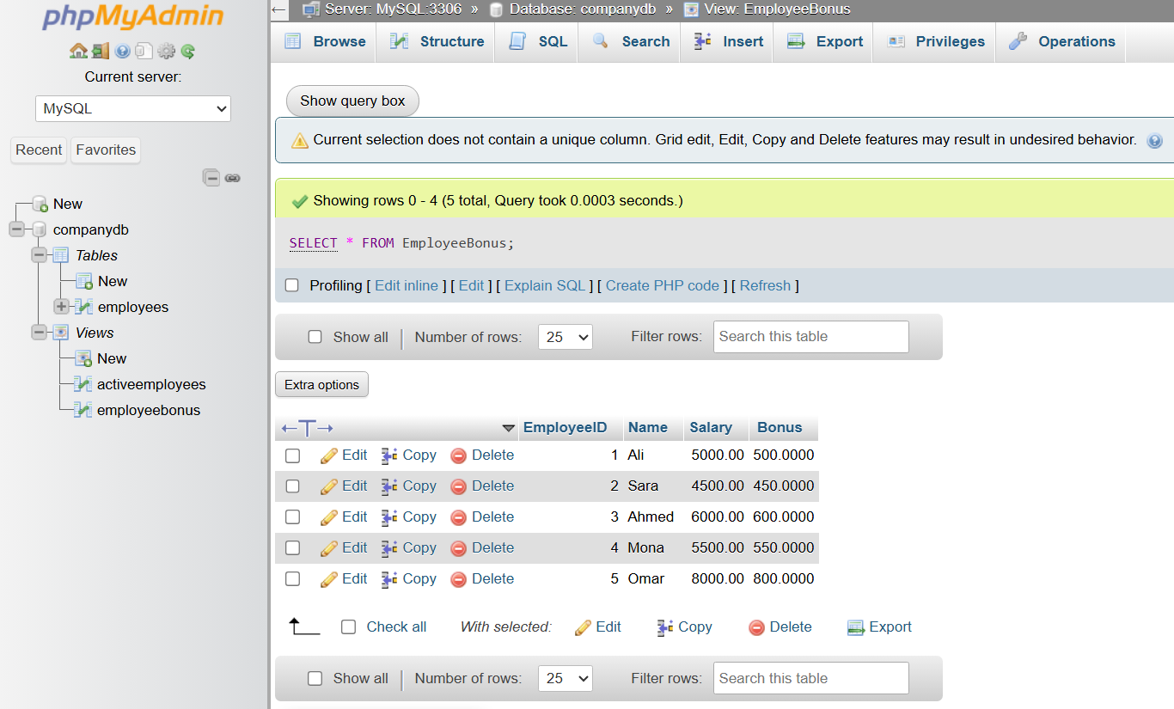

8️⃣ Create a View Using ORDER BY
# Source: ScreenShot Source: Provided by: [Persons Table -> ID Column: 1, Name_En Column: Motasem Essam] -> Tool: [Automation Table -> ID Column: 16, Name_En Column: Screen Capture] -> From [Operating System: Wampserver64 -> phpmyadmin] on [6/11/2026]
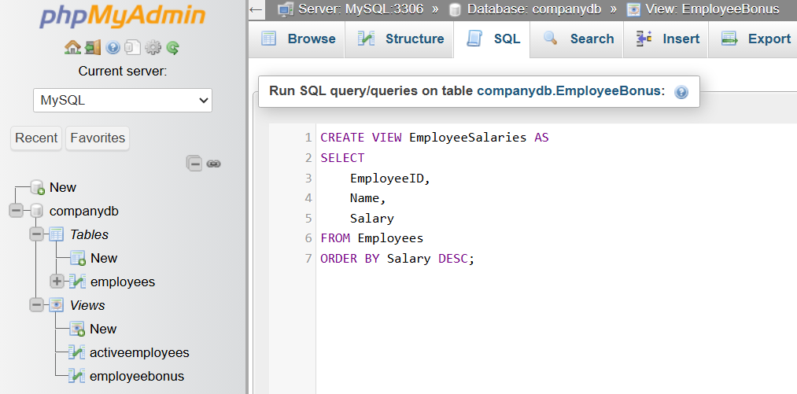
CREATE VIEW EmployeeSalaries AS
SELECT
EmployeeID,
Name,
Salary
FROM Employees
ORDER BY Salary DESC;
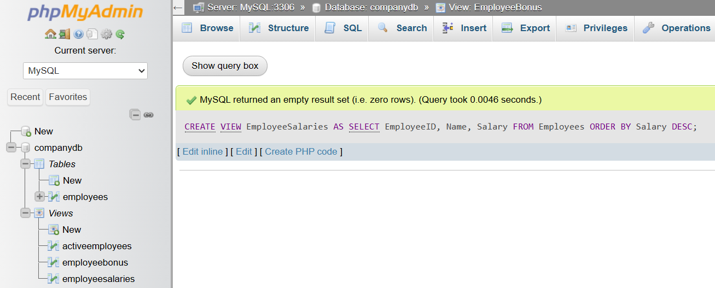
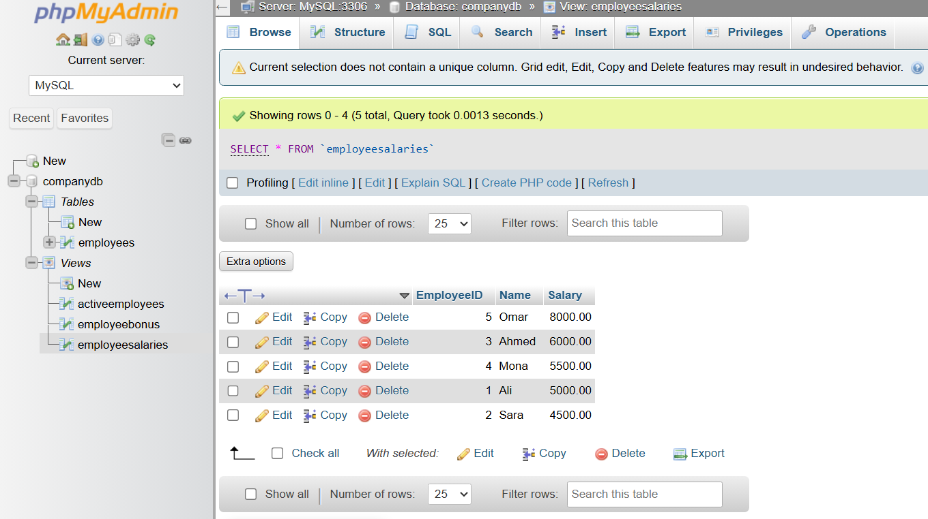

9️⃣ Replace a View (MySQL)
# Source: ScreenShot Source: Provided by: [Persons Table -> ID Column: 1, Name_En Column: Motasem Essam] -> Tool: [Automation Table -> ID Column: 16, Name_En Column: Screen Capture] -> From [Operating System: Wampserver64 -> phpmyadmin] on [6/11/2026]
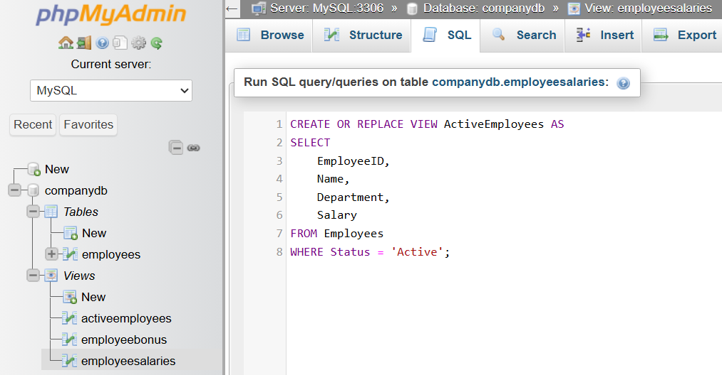
CREATE OR REPLACE VIEW ActiveEmployees AS
SELECT
EmployeeID,
Name,
Department,
Salary
FROM Employees
WHERE Status = 'Active';
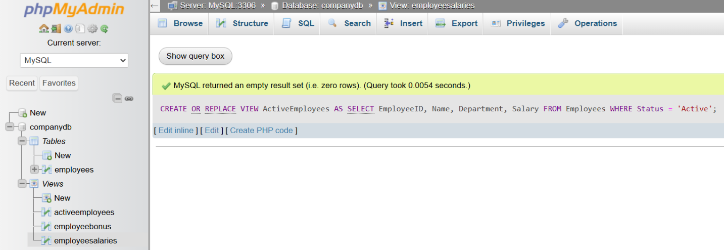
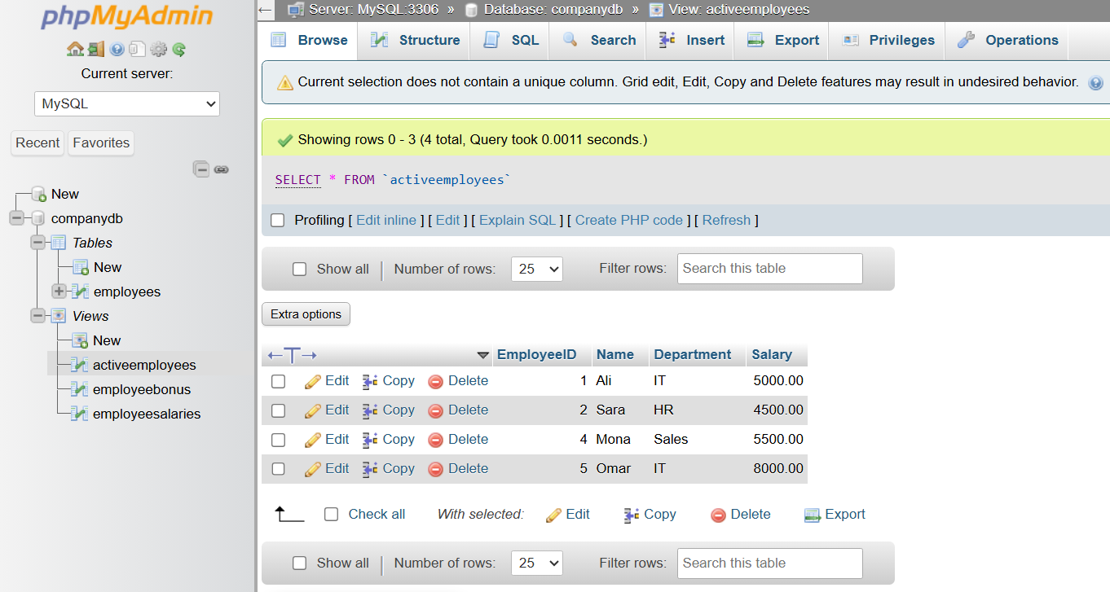

🔟 Show View Definition
# Source: ScreenShot Source: Provided by: [Persons Table -> ID Column: 1, Name_En Column: Motasem Essam] -> Tool: [Automation Table -> ID Column: 16, Name_En Column: Screen Capture] -> From [Operating System: Wampserver64 -> phpmyadmin] on [6/11/2026]
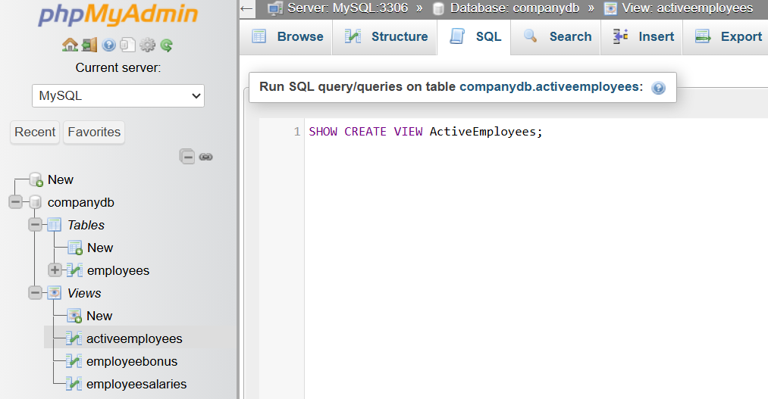
SHOW CREATE VIEW ActiveEmployees;
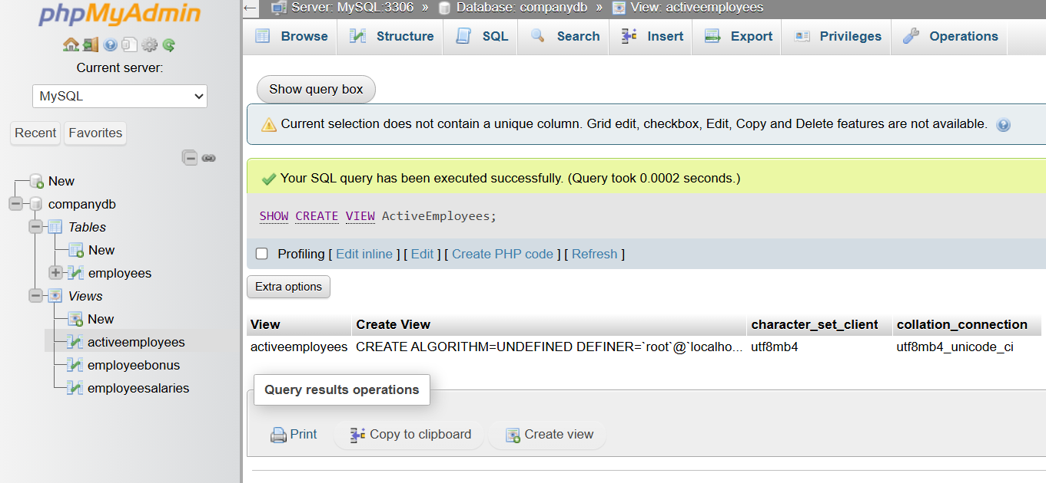

1️⃣1️⃣ List All Views
# Source: ScreenShot Source: Provided by: [Persons Table -> ID Column: 1, Name_En Column: Motasem Essam] -> Tool: [Automation Table -> ID Column: 16, Name_En Column: Screen Capture] -> From [Operating System: Wampserver64 -> phpmyadmin] on [6/11/2026]
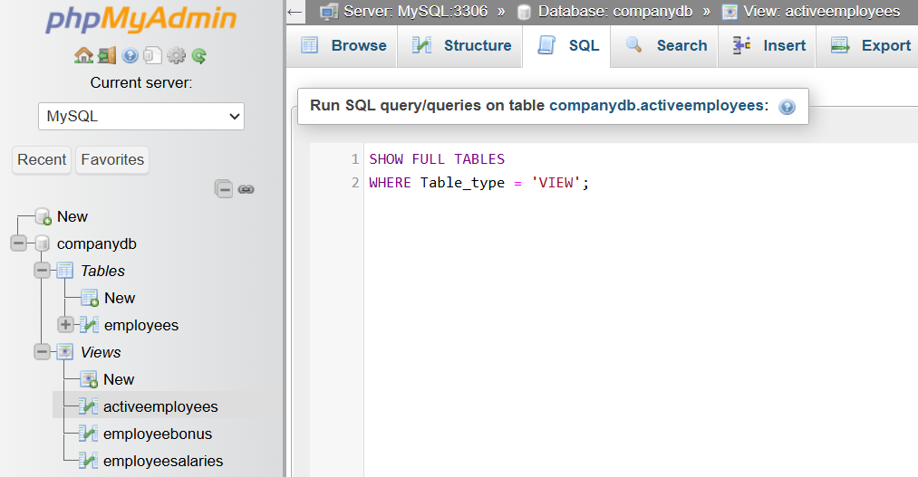
SHOW FULL TABLES
WHERE Table_type = 'VIEW';
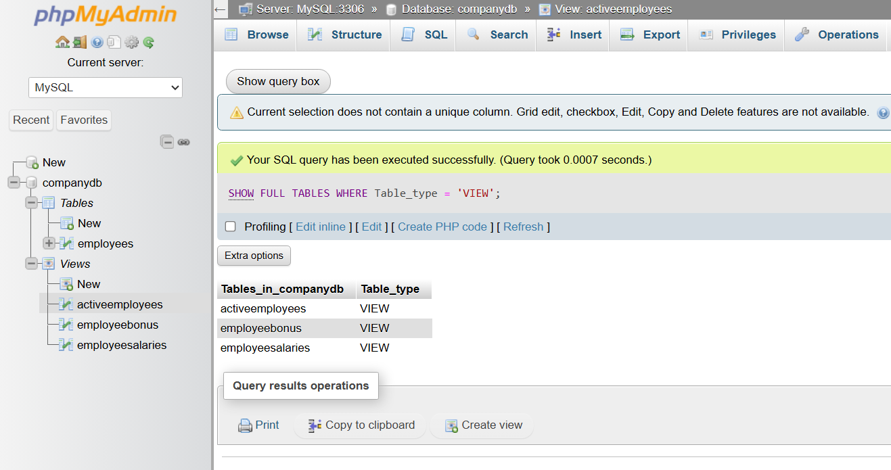

1️⃣2️⃣ Delete a View
# Source: ScreenShot Source: Provided by: [Persons Table -> ID Column: 1, Name_En Column: Motasem Essam] -> Tool: [Automation Table -> ID Column: 16, Name_En Column: Screen Capture] -> From [Operating System: Wampserver64 -> phpmyadmin] on [6/11/2026]
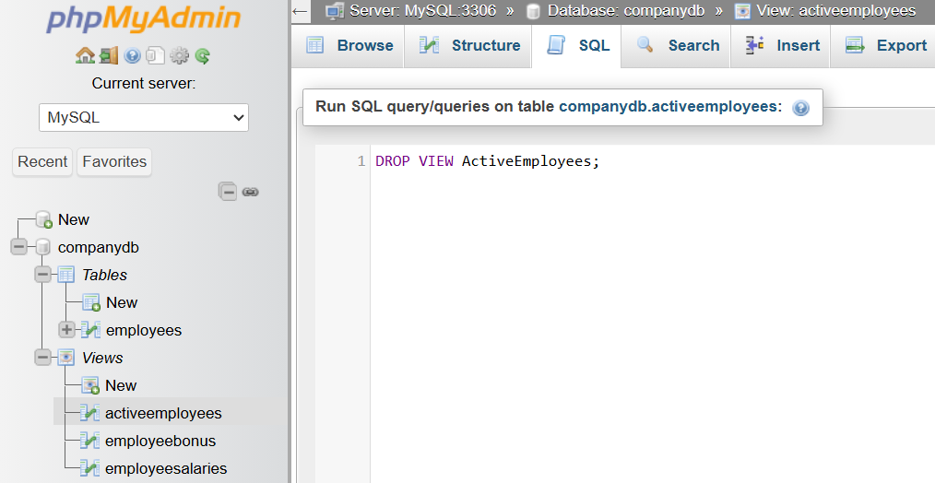
DROP VIEW ActiveEmployees;
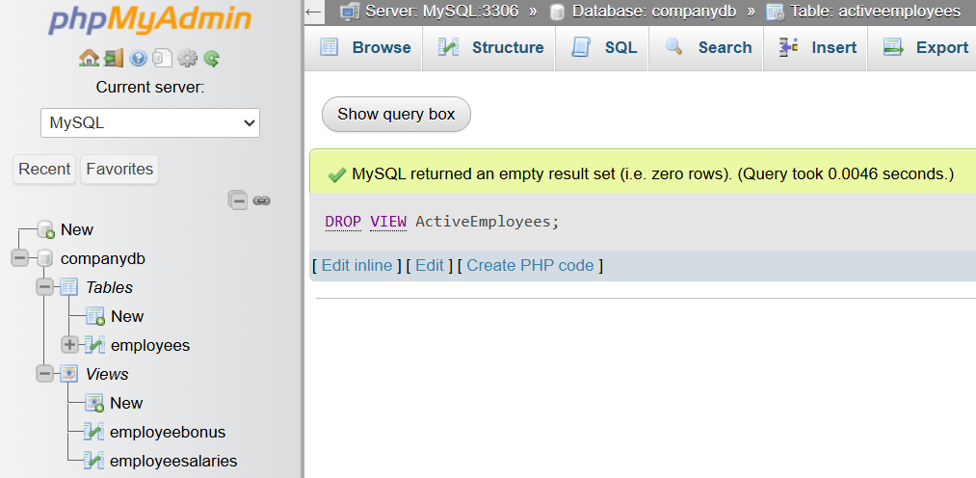

1️⃣3️⃣ Verify Views Were Removed
# Source: ScreenShot Source: Provided by: [Persons Table -> ID Column: 1, Name_En Column: Motasem Essam] -> Tool: [Automation Table -> ID Column: 16, Name_En Column: Screen Capture] -> From [Operating System: Wampserver64 -> phpmyadmin] on [6/11/2026]
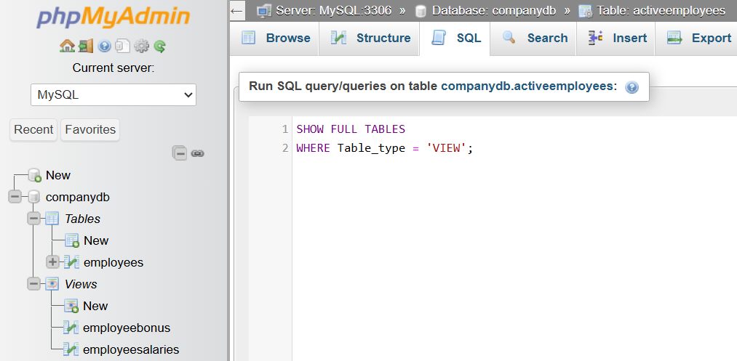
SHOW FULL TABLES
WHERE Table_type = 'VIEW';
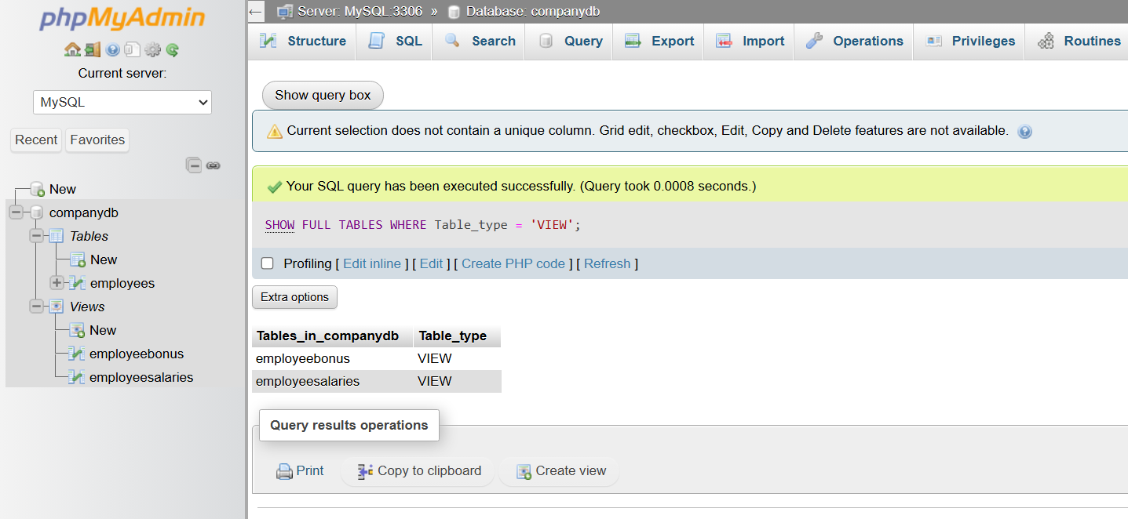

🔢 View Lifecycle
# Source: AI Source: Provided by: [Data Path: Persons Table -> ID Column: 1, Name_En Column: Motasem Essam] -> From: [ChatGPT] on [6/11/2026]
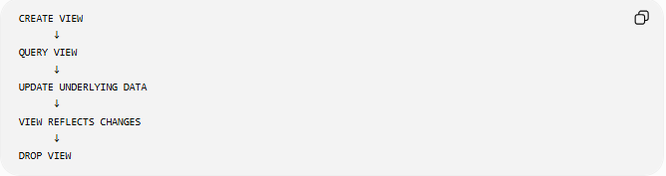
CREATE VIEW
↓
QUERY VIEW
↓
UPDATE UNDERLYING DATA
↓
VIEW REFLECTS CHANGES
↓
DROP VIEW

🧠 Simple Analogy
# Source: AI Source: Provided by: [Data Path: Persons Table -> ID Column: 1, Name_En Column: Motasem Essam] -> From: [ChatGPT] on [6/11/2026]
Think of a view as a window.
Table = Entire Building
View = Window
The building contains all information.
The window shows only the part you want to see.
Similarly:
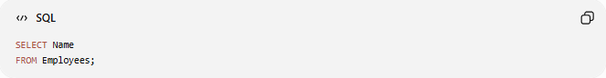
SELECT Name
FROM Employees;
can be saved as a view that shows only employee names while hiding other data.

🧭 Summary
# Source: AI Source: Provided by: [Data Path: Persons Table -> ID Column: 1, Name_En Column: Motasem Essam] -> From: [ChatGPT] on [6/11/2026]
A SQL View is a virtual table based on the result of a SQL query. It does not typically store data itself but presents data from one or more underlying tables. Views are used to simplify complex queries, improve security, hide sensitive information, and provide customized ways of viewing data. Common operations include CREATE VIEW, SELECT FROM View, and DROP VIEW.

